Learners have to come up with a Report to support the answers to the following questions and suggestions

Objective Questions

- Does any table have missing values or duplicates? If yes how would you handle it ?
customer table has null values for the following columns :
- company, state, fax, postal_code, phone
Employee table has null values in reports_to column.
Handling Missing Values:
- If NULLs exist, investigate the data source as these fields should always be populated. Missing values in primary keys indicate data integrity issues.
- If missing, it may suggest orphaned records that require further investigation.
- Remove records if they are not useful.
- Assign a default or placeholder value, such as Unknown Customer.
- Text Columns, for example company, address: replace missing values with "Unknown" or an empty string ('').
- Numeric Columns, for example unit_price, total: use COALESCE(column, default_value) to replace missing values with suitable defaults, such as 0 for monetary values.
Dealing with Duplicate Data
- In case of primary key duplicates, investigate the source system. If errors are present, correct or remove the duplicate rows.
- Keep only the last record as ordered by invoice_date.
- Drop the duplicates using DISTINCT or ROW_NUMBER() in case all the fields are equal.
- Apply the aggregation methods as needed, like SUM for totals.
- Find the top-selling tracks and top artists in the USA and identify their most famous genres.
Query :
WITH usa_sales AS (

SELECT il.track_id, il.quantity, il.unit_price,
t.name AS track_name, a.artist_id, ar.name AS artist_name, g.genre_id, g.name AS genre_name, i.billing_country
FROM invoice i
JOIN invoice_line il ON i.invoice_id = il.invoice_id
JOIN track t ON il.track_id = t.track_id
JOIN album a ON t.album_id = a.album_id
JOIN artist ar ON a.artist_id = ar.artist_id
JOIN genre g ON t.genre_id = g.genre_id
WHERE i.billing_country = 'USA'
)
SELECT
us.track_name AS top_selling_track,
us.artist_name AS top_artist,
us.genre_name AS most_famous_genre,
SUM(us.quantity * us.unit_price) AS total_sales,
billing_country
FROM usa_sales us
GROUP BY us.track_id, us.artist_id, us.genre_id
ORDER BY total_sales DESC
LIMIT 10;

Output :
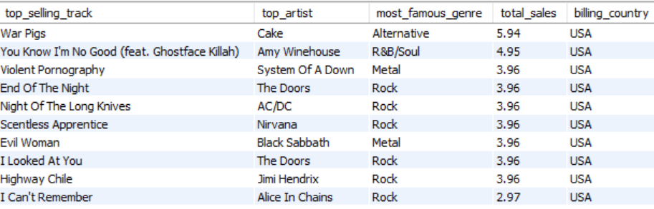
Explanation :
Rock and Metal Dominate: Rock and Metal genres are heavily represented among the top-selling tracks, suggesting a strong preference for these genres within the dataset.
The Doors and AC/DC are Popular: The Doors and AC/DC both have multiple tracks among the top sellers, indicating their popularity and consistent sales performance.

- What is the customer demographic breakdown (age, gender, location) of Chinook's customer base?
Query :
AgeGroup calculation :
WITH cte AS (
SELECT
country,
timestampdiff(YEAR, birthdate, curdate()) AS age
FROM
employee
),
age_groups AS (
SELECT
country,
CASE
WHEN age BETWEEN 51 AND 57 THEN '51-57'
WHEN age BETWEEN 58 AND 64 THEN '58-64'
WHEN age BETWEEN 65 AND 71 THEN '65-71'
END AS age_group
FROM
cte
WHERE
age BETWEEN 51 AND 71
)
SELECT
ag.age_group,
COUNT(ct.customer_id) AS customer_count
FROM
age_groups ag
JOIN
customer ct ON ag.country = ct.country
GROUP BY
ag.age_group;

Location :
SELECT
Country,
COUNT(*) AS Customer_Count
FROM
Customer
GROUP BY
Country
ORDER BY
customer_count DESC
Output :
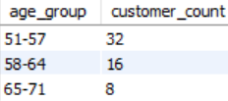

Insights:
- The 51-57 age group has the highest customer count, representing 57.1% of the total. This suggests that this age group is the most significant customer segment for the business.
- Customers aged 65-71 make up the smallest segment, accounting for only 14.3% of the total. This implies that the business may need to focus on strategies to attract and retain customers in this age group.

- Calculate the total revenue and number of invoices for each country, state, and city.
Query :
SELECT
c.country,
c.state,
c.city,
SUM(i.total) AS total_revenue,
COUNT(i.invoice_id) AS number_of_invoices
FROM
customer c
JOIN
invoice i ON c.customer_id = i.customer_id
GROUP BY
c.country, c.state, c.city
Order by number_of_invoices desc
Output :
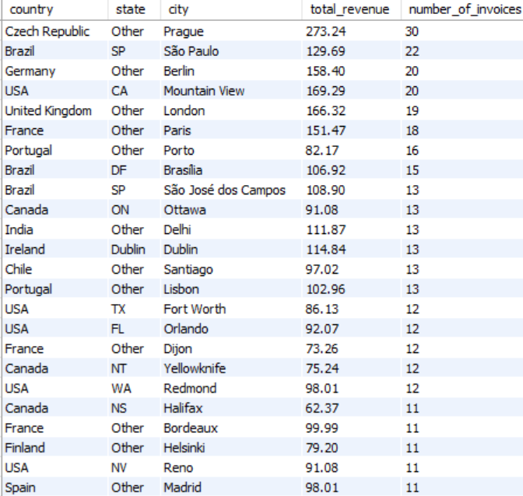
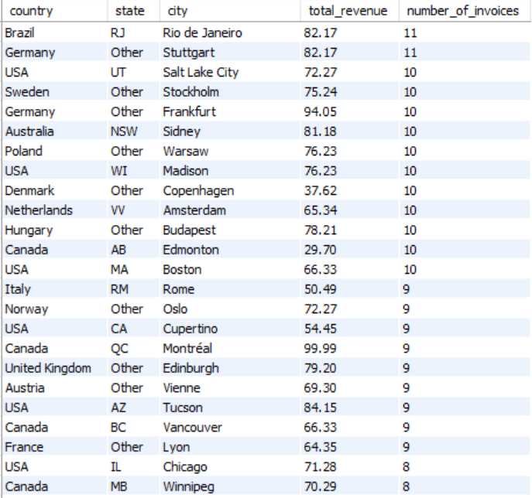
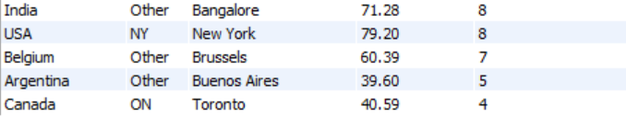
Insights:
- The USA and Canada stand out with the highest total revenue and number of invoices, indicating strong market presence and sales activity in these regions.
- Several Western European countries (France, Germany, UK) also show significant sales activity, indicating a considerable market share in this region.
- A long tail of countries exhibit much lower sales activity, suggesting a less significant market presence or lower customer engagement.

- Find the top 5 customers by total revenue in each country.
Query :
WITH CustomerRevenue AS (
SELECT
c.customer_id,
c.first_name,
c.last_name,
c.country,
SUM(il.unit_price * il.quantity) AS total_revenue
FROM customer c
JOIN invoice i ON c.customer_id = i.customer_id
JOIN invoice_line il ON i.invoice_id = il.invoice_id
GROUP BY c.customer_id, c.first_name, c.last_name, c.country
),
RankedCustomers AS (
SELECT
cr.customer_id,
cr.first_name,
cr.last_name,
cr.country,
cr.total_revenue,
ROW_NUMBER() OVER (PARTITION BY cr.country ORDER BY cr.total_revenue DESC) AS revenue_rank
FROM CustomerRevenue cr
)
SELECT
rc.customer_id,
rc.first_name,
rc.last_name,
rc.country,
rc.total_revenue
FROM RankedCustomers rc
WHERE rc.revenue_rank <= 5
ORDER BY rc.country,rc.total_revenue;
Output :
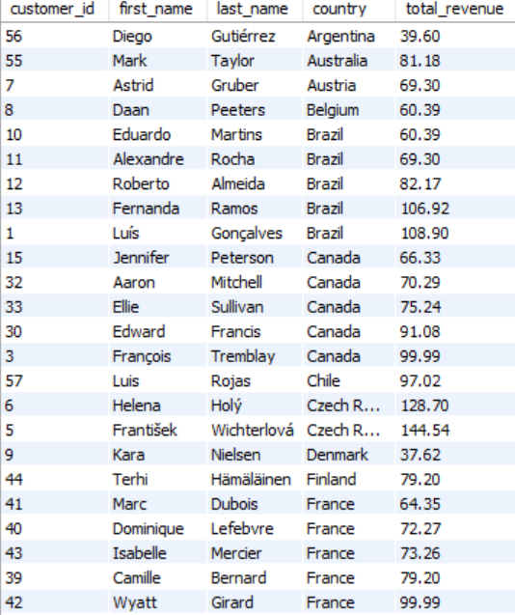
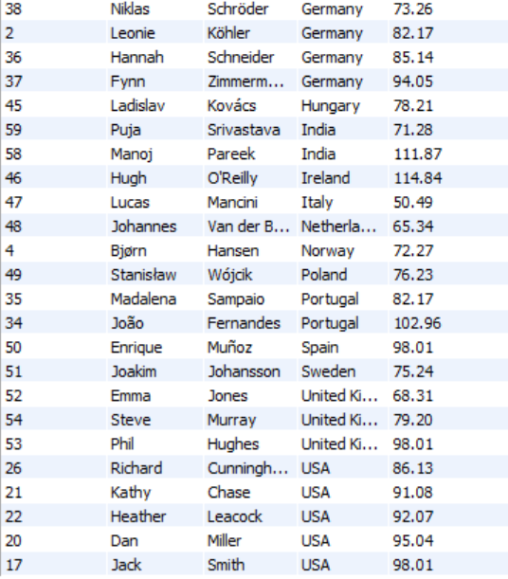

Insights :
- Europe: A significant number of customers are from European countries, and several show high revenue generation (e.g., Czech Republic, Germany, France).
- North America: The USA has a notable presence with high-revenue customers.
- South America: Brazil stands out with multiple high-revenue customers.

- Identify the top-selling track for each customer.
Query :

WITH TrackSales AS (
SELECT i.customer_id,
c.first_name,
c.last_name,
il.track_id,
t.name AS track_name,
SUM(il.quantity) AS total_purchased
FROM invoice i
JOIN invoice_line il ON i.invoice_id = il.invoice_id
JOIN track t ON il.track_id = t.track_id
JOIN customer c ON i.customer_id = c.customer_id
GROUP BY i.customer_id, c.first_name, c.last_name, il.track_id, t.name
),
RankedTracks AS (
SELECT ts.*,
ROW_NUMBER() OVER (PARTITION BY customer_id ORDER BY total_purchased DESC, track_id ASC) AS row_num
FROM TrackSales ts
)
SELECT customer_id,
first_name,
last_name,
track_id,
track_name,
total_purchased
FROM RankedTracks
WHERE row_num = 1
ORDER BY customer_id;

Output :
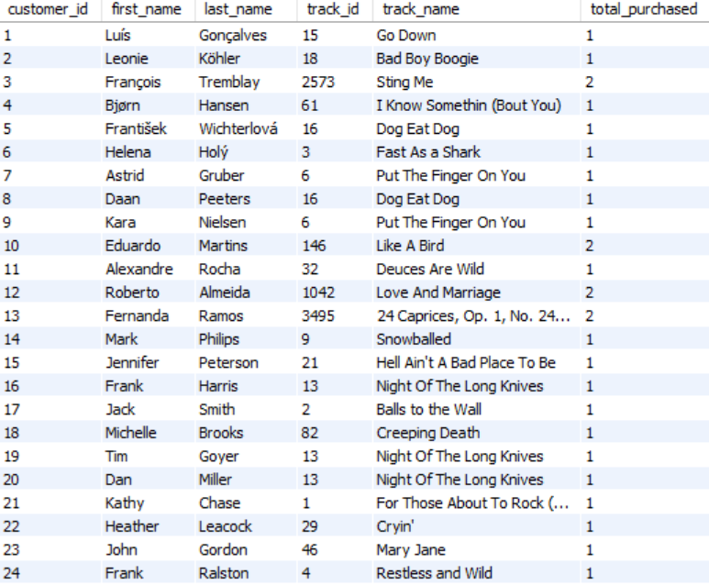
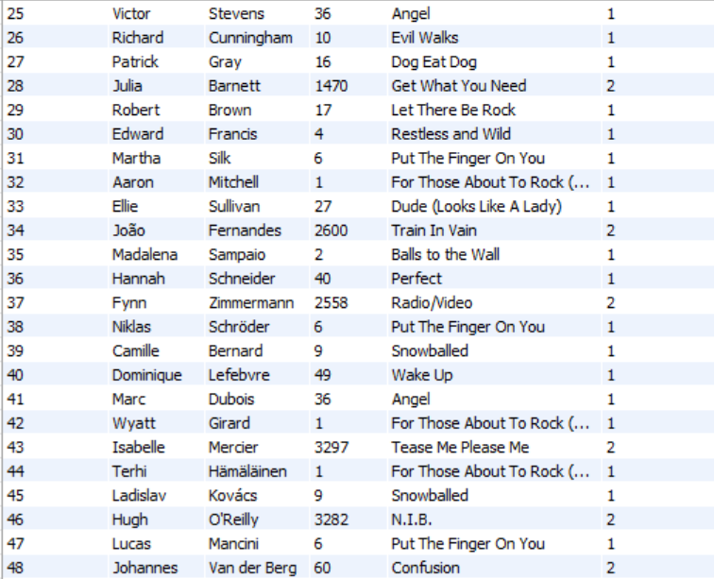
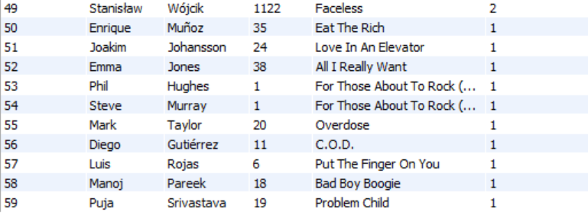

Insights :
- "For Those About To Rock (We Salute You)" is a popular track, appearing multiple times in the list of purchases. This suggests it's a well-liked and frequently bought song.
- It could be used to analyze purchasing trends, identify popular artists and albums, and personalize recommendations.

- Are there any patterns or trends in customer purchasing behavior (e.g., frequency of purchases, preferred payment methods, average order value)?
Purchasing frequency :
Query :
WITH purchase_gaps AS (
SELECT
i.customer_id,
i.invoice_date,
LAG(i.invoice_date) OVER (PARTITION BY i.customer_id ORDER BY i.invoice_date) AS previous_invoice_date
FROM invoice i
)
SELECT
c.customer_id,
c.first_name,
c.last_name,
COUNT(i.invoice_id) AS total_purchases,
ROUND(AVG(DATEDIFF(i.invoice_date, pg.previous_invoice_date)), 2) AS avg_days_between_purchases
FROM customer c
LEFT JOIN invoice i ON c.customer_id = i.customer_id
LEFT JOIN purchase_gaps pg ON i.customer_id = pg.customer_id AND i.invoice_date = pg.invoice_date
WHERE pg.previous_invoice_date IS NOT NULL -- Exclude first purchase (no previous date)
GROUP BY c.customer_id, c.first_name, c.last_name
ORDER BY total_purchases DESC;
Output :
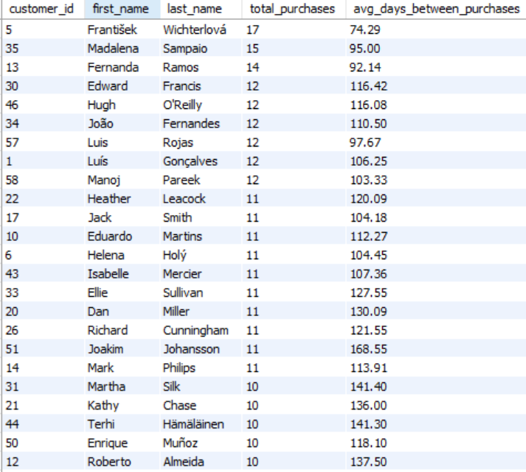
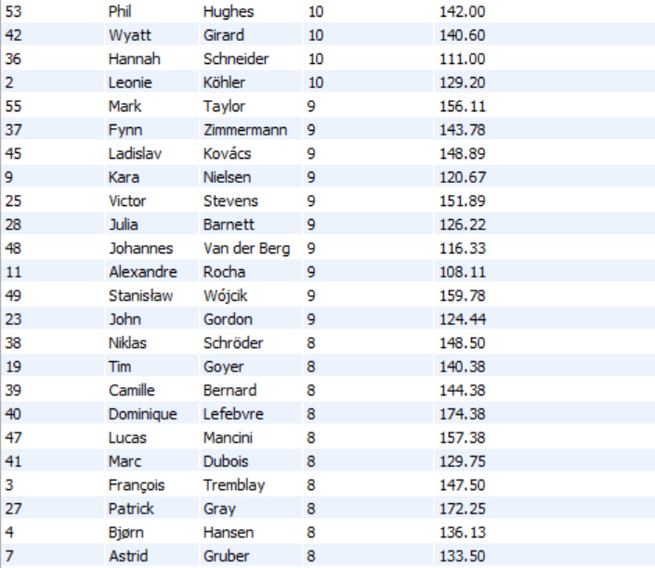
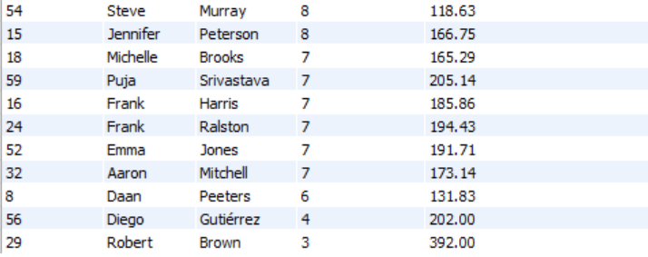

Average order value :
Query :
SELECT
c.customer_id,
c.first_name,
c.last_name,
COUNT(i.invoice_id) AS total_orders,
SUM(i.total) AS total_spent,
ROUND(AVG(i.total), 2) AS avg_order_value
FROM customer c
LEFT JOIN invoice i ON c.customer_id = i.customer_id
GROUP BY c.customer_id, c.first_name, c.last_name
ORDER BY avg_order_value DESC;
Output :
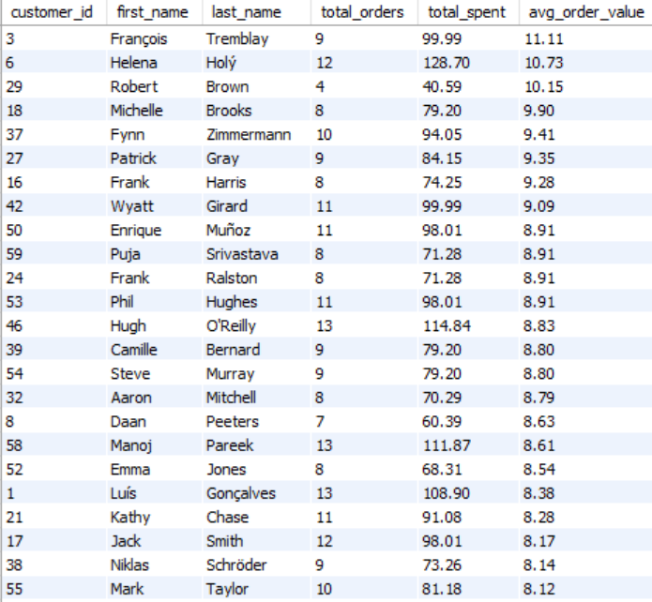
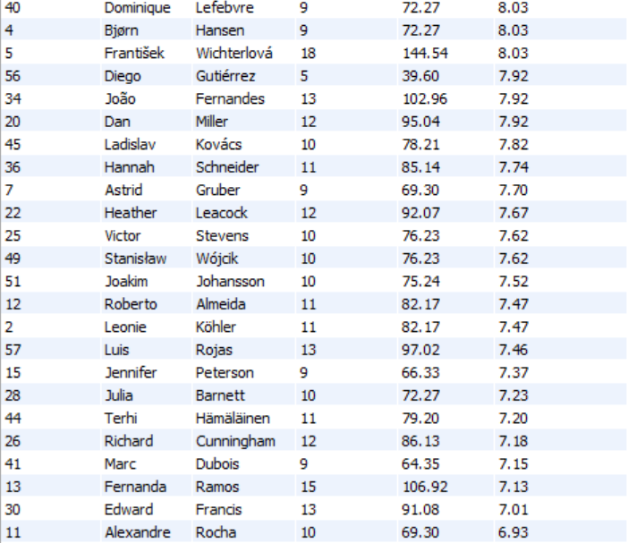
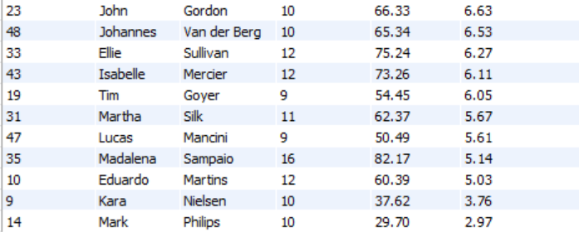
Insights :
- Customer ID 29, which has the lowest purchase count of 3 and the largest average between transactions of 392 days, customer ID 5 has the highest purchase count of 17 and the fewest days between purchases of 74.29.
- Customer ID 14 has the lowest average order value of 2.97, customer ID 3 has highest average order value of 11.11.

- What is the customer churn rate?
The rate at which customers leave a company (stop using their products or services).
Query :
WITH customer_activity AS (
-- Find the last purchase date for each customer
SELECT
c.customer_id,
MAX(i.invoice_date) AS last_purchase_date
FROM customer c
LEFT JOIN invoice i ON c.customer_id = i.customer_id
GROUP BY c.customer_id
),
churned_customers AS (
-- Identify customers who have not made a purchase in the last 6 months
SELECT COUNT(*) AS churned_count
FROM customer_activity
WHERE last_purchase_date < DATE_SUB('2020-12-31 00:00:00', INTERVAL 6 MONTH)
),
total_customers AS (
-- Count total customers at the start of the period
SELECT COUNT(*) AS total_count FROM customer
)
-- Calculate churn rate
SELECT
ROUND((chc.churned_count / tc.total_count) * 100,2) AS churn_rate
FROM churned_customers chc, total_customers tc;
Output :
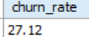
Insights :
- Identify Churned Customers: The churned_customers CTE counts customers whose last purchase was more than 6 months before December 31, 2020 (i.e., before June 30, 2020), indicating inactivity.
- Calculate Churn Rate: The final query computes the churn rate as the percentage of churned customers out of the total customer base.
- Customer churn rate is 27.12 %.

9. Calculate the percentage of total sales contributed by each genre in the USA and identify the best-selling genres and artists.
Query :
WITH genre_sales AS (
-- Calculate total sales per genre in the USA
SELECT
g.genre_id,
g.name AS genre_name,
SUM(il.unit_price * il.quantity) AS total_genre_sales
FROM invoice i
JOIN invoice_line il ON i.invoice_id = il.invoice_id
JOIN track t ON il.track_id = t.track_id
JOIN genre g ON t.genre_id = g.genre_id
WHERE i.billing_country = 'USA'
GROUP BY g.genre_id, g.name
),
total_sales AS (
-- Calculate total sales in the USA
SELECT SUM(il.unit_price * il.quantity) AS total_usa_sales
FROM invoice i
JOIN invoice_line il ON i.invoice_id = il.invoice_id
WHERE i.billing_country = 'USA'
)
-- Compute percentage contribution of each genre
SELECT
gs.genre_name,
ROUND((gs.total_genre_sales / ts.total_usa_sales) * 100, 2) AS sales_percentage
FROM genre_sales gs, total_sales ts
ORDER BY sales_percentage DESC;

Output :
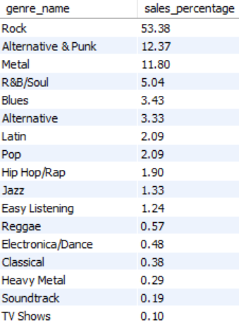
Query :
WITH artist_sales AS (
-- Calculate total sales per artist in the USA
SELECT
a.artist_id,
a.name AS artist_name,
SUM(il.unit_price * il.quantity) AS total_artist_sales
FROM invoice i
JOIN invoice_line il ON i.invoice_id = il.invoice_id
JOIN track t ON il.track_id = t.track_id
JOIN album al ON t.album_id = al.album_id
JOIN artist a ON al.artist_id = a.artist_id
WHERE i.billing_country = 'USA'
GROUP BY a.artist_id, a.name
)
-- Rank artists by total sales in the USA
SELECT
artist_name,
total_artist_sales
FROM artist_sales
ORDER BY total_artist_sales DESC
LIMIT 10; -- Top 10 best-selling artists
Output :
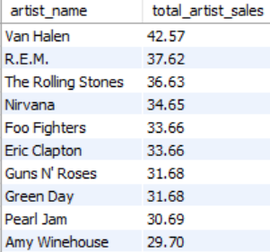
Insights :
- Rock music makes up more than half of all sales, at 53.38%. This highlights its enduring popularity compared to other genres.
- Rock, Alternative & Punk, and Metal are the top 3 genres that account for over 77% of all music sales, showing their strong market presence.
- Van Halen is the top-selling artist with 42.57 in total sales, Van Halen leads the list of artists.
- The top 3 artists account for a significant portion of total sales are Van Halen, R.E.M., and The Rolling Stones combined account for a significant portion of the total sales, indicating their strong market presence.
10. Find customers who have purchased tracks from at least 3 different genres.
Query :
WITH customer_genre_count AS (
-- Count unique genres each customer has purchased from
SELECT
i.customer_id,
COUNT(DISTINCT g.genre_id) AS genre_count
FROM invoice i
JOIN invoice_line il ON i.invoice_id = il.invoice_id
JOIN track t ON il.track_id = t.track_id
JOIN genre g ON t.genre_id = g.genre_id
GROUP BY i.customer_id
)
-- Select customers with at least 3 different genres
SELECT
c.customer_id,
c.first_name,
c.last_name,
cg.genre_count as unique_genre_count
FROM customer_genre_count cg
JOIN customer c ON cg.customer_id = c.customer_id
WHERE cg.genre_count >= 3
ORDER BY cg.genre_count DESC;
Output :
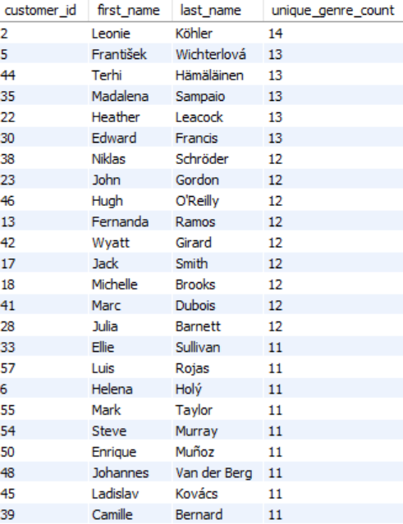
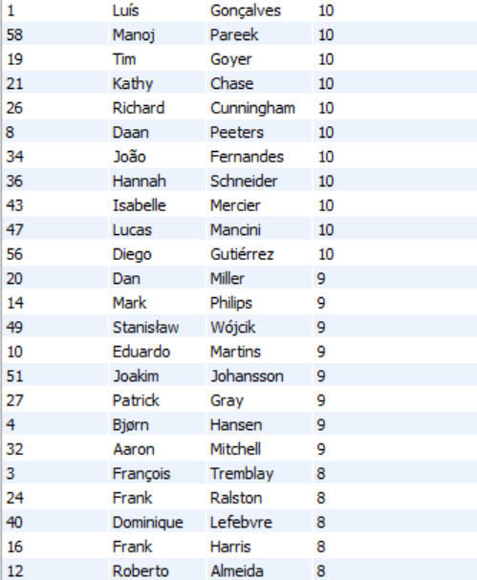
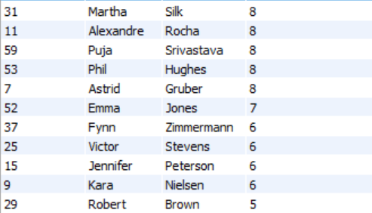
Insights :
1.Customer ID 29 has purchased 5(least) different genres of tracks
2.Customer ID 2 has purchased 14 different genres of tracks which covers almost all genres.

11.Rank genres based on their sales performance in the USA.
Query :
WITH genre_sales AS (
-- Calculate total sales per genre in the USA
SELECT
g.genre_id,
g.name AS genre_name,
SUM(il.unit_price * il.quantity) AS total_sales
FROM invoice i
JOIN invoice_line il ON i.invoice_id = il.invoice_id
JOIN track t ON il.track_id = t.track_id
JOIN genre g ON t.genre_id = g.genre_id
WHERE i.billing_country = 'USA'
GROUP BY g.genre_id, g.name
)
-- Rank genres based on total sales in descending order
SELECT
genre_name,
total_sales,
RANK() OVER (ORDER BY total_sales DESC) AS sales_rank
FROM genre_sales;
Output :
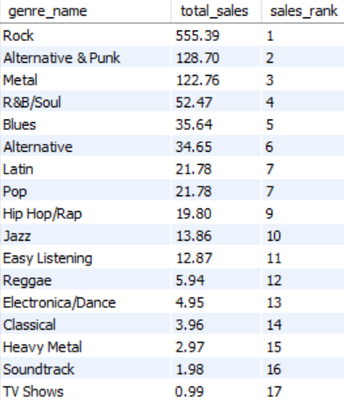

Insights :
- Rock significantly outperforms all other genres in total sales, with 555.39 units sold, holding the top sales rank.

- Latin and Pop have identical total sales and share the same sales rank (7), suggesting comparable market performance.

12. Identify customers who have not made a purchase in the last 3 months.
Query :
WITH customer_last_purchase AS (
-- Find the last purchase date for each customer
SELECT
c.customer_id,
CONCAT(c.first_name, ' ', c.last_name) AS customer_name,
MAX(i.invoice_date) AS last_purchase_date
FROM customer c
LEFT JOIN invoice i ON c.customer_id = i.customer_id
GROUP BY c.customer_id
)
-- Selecting customers who haven't made a purchase in the last 3 months
SELECT
customer_id,
customer_name,
last_purchase_date
FROM customer_last_purchase
WHERE last_purchase_date < DATE_SUB('2020-12-30', INTERVAL 3 MONTH)
ORDER BY customer_id,last_purchase_date ASC;
Output :

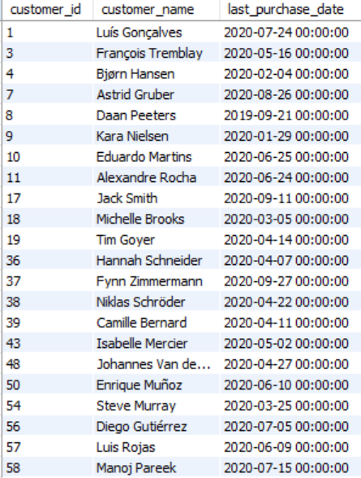

Insights :
There are 22 among 59 customers who have not made a purchase in the last 3 months.

Subjective Questions

- Recommend the three albums from the new record label that should be prioritised for advertising and promotion in the USA based on genre sales analysis.
Query :

WITH GenreSales AS (
SELECT
g.genre_id,
g.name AS genre_name,
SUM(il.unit_price * il.quantity) AS total_sales
FROM invoice_line il
JOIN track t ON il.track_id = t.track_id
JOIN genre g ON t.genre_id = g.genre_id
JOIN invoice i ON il.invoice_id = i.invoice_id
WHERE i.billing_country = 'USA'
GROUP BY g.genre_id, g.name
),

TopGenres AS (
SELECT
genre_id,
genre_name
FROM GenreSales
ORDER BY total_sales DESC
LIMIT 3
),

TopArtists AS (
SELECT
a.artist_id,
a.name AS artist_name,
SUM(il.unit_price * il.quantity) AS artist_sales
FROM invoice_line il
JOIN track t ON il.track_id = t.track_id
JOIN album al ON t.album_id = al.album_id
JOIN artist a ON al.artist_id = a.artist_id
JOIN invoice i ON il.invoice_id = i.invoice_id
WHERE i.billing_country = 'USA'
AND t.genre_id IN (SELECT genre_id FROM TopGenres)
GROUP BY a.artist_id, a.name
ORDER BY artist_sales DESC
LIMIT 3
),

TopAlbums AS (
SELECT
al.album_id,
al.title AS album_title,
a.name AS artist_name,
SUM(il.unit_price * il.quantity) AS album_sales
FROM invoice_line il
JOIN track t ON il.track_id = t.track_id
JOIN album al ON t.album_id = al.album_id
JOIN artist a ON al.artist_id = a.artist_id
JOIN invoice i ON il.invoice_id = i.invoice_id
WHERE i.billing_country = 'USA'
AND a.artist_id IN (SELECT artist_id FROM TopArtists)
GROUP BY al.album_id, al.title, a.name
ORDER BY album_sales DESC
LIMIT 3
)

SELECT * FROM TopAlbums;

Album details output :
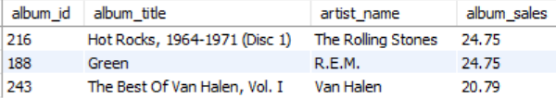

Approach:
- Genre Sales: Calculate total sales for each genre in the USA, identifying the top 3 genres by sales.
- Top Artists: From the top 3 genres, identify the top 3 artists based on their total sales in the USA.
- Top Albums: From the top artists, find the top 3 albums by sales in the USA.

Insights :
Rock: As the dominant genre with over half of the total sales (53.38%), Rock should be the top priority for advertising and promotion. It has a strong and established market in the USA and continues to attract a large audience.
Alternative & Punk: With 12.37% of the market share, Alternative & Punk holds significant potential. This genre has a dedicated following and can be effectively targeted through specific channels and platforms.
Metal: At 11.80% of the market share, Metal is another genre with a substantial audience in the USA. Advertising and promotion efforts should focus on reaching existing fans and exploring opportunities to expand its reach to new listeners.

Recommendations:
- Focus marketing campaigns on the top 3 genres and their leading artists to maximize sales and audience engagement.
- Promote the top albums through targeted ads, exclusive content, and collaborations with the artists to further boost sales.
- Expand the catalog for the most popular genres by acquiring more tracks/albums to cater to the high demand in the USA.

2. Determine the top-selling genres in countries other than the USA and identify any commonalities or differences.
Query :
SELECT g.name AS genre,
SUM(il.quantity * il.unit_price) AS total_sales,
COUNT(DISTINCT c.country) AS countries_count
FROM invoice_line il JOIN invoice i ON il.invoice_id = i.invoice_id
JOIN customer c ON i.customer_id = c.customer_id
JOIN track t ON il.track_id = t.track_id
JOIN genre g ON t.genre_id = g.genre_id
WHERE c.country != 'USA' GROUP BY g.name
HAVING countries_count > 0
ORDER BY total_sales DESC;

Output :
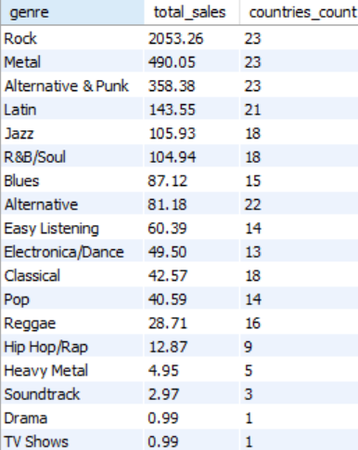
Approach :
- Purpose: This query analyzes the total sales revenue generated from different genres across countries (excluding the USA) and counts the number of unique countries contributing to each genre's sales.
- Key Steps:
  - JOINs: Combine tables (invoice_line, invoice, customer, track, genre) to associate sales, customers, tracks, and genres.
  - Filter: Exclude customers from the USA using c.country != 'USA'.
  - Aggregate:
    - SUM(il.quantity * il.unit_price): Calculate total sales revenue for each genre.
    - COUNT(DISTINCT c.country): Count unique countries for each genre.
  - Filter Groups: Use HAVING countries_count > 0 to exclude genres with no sales outside the USA.
  - Sort: Order genres by total sales in descending order.

Insights :
- Rock has the highest total sales (2053.26) and is popular in all 23 countries represented in the data.
- Metal and Alternative & Punk also reach all 23 countries and have significantly higher sales than most other genres, indicating a widespread appeal.\
- Genres like Heavy Metal, Soundtrack, Drama, and TV Shows have low sales and are present in only a few countries, indicating they cater to smaller, more localized audiences.
Recommendations :
- Insight Expansion: Include additional filters or breakdowns, such as customer demographics (e.g., age, membership) or time periods (e.g., quarterly sales trends), to gain more nuanced insights into genre preferences and international market trends.
- Boost International Sales: Focus on promoting top-performing genres with high revenue and global reach in countries outside the USA to maximize growth potential.
- Genre Strategy: Use the results to identify low-performing genres with fewer international reach and explore opportunities to expand their global appeal.

3. Customer Purchasing Behavior Analysis: How do the purchasing habits (frequency, basket size, spending amount) of long-term customers differ from those of new customers? What insights can these patterns provide about customer loyalty and retention strategies?
Average Customer Spending by Country :
SELECT c.country,
-- COUNT(DISTINCT c.customer_id) AS total_customers,
SUM(i.total) AS total_revenue,
(SUM(i.total) / COUNT(DISTINCT c.customer_id)) AS avg_spending_per_customer
FROM customer c
JOIN invoice i ON c.customer_id = i.customer_id
GROUP BY c.country
ORDER BY avg_spending_per_customer DESC
Output :
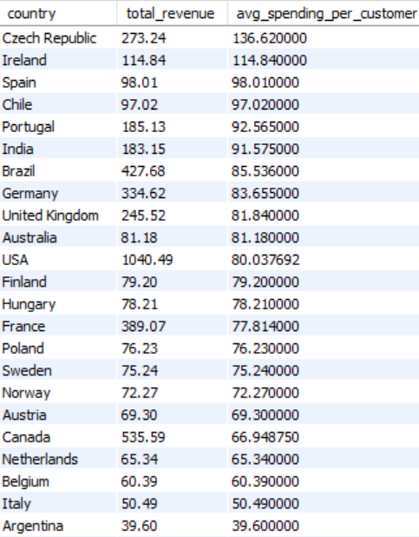
Visualisation :
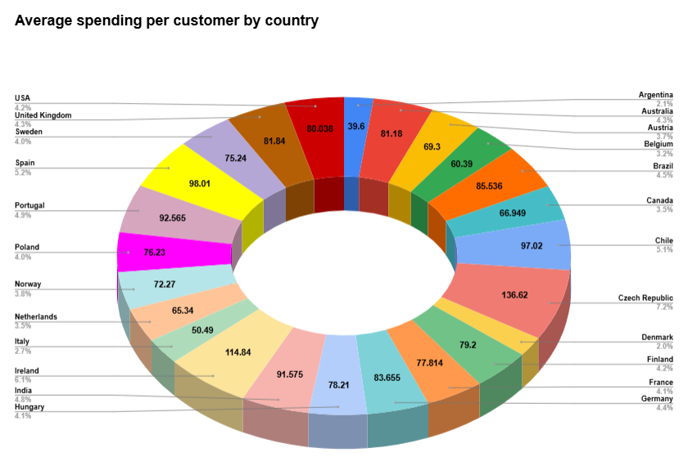
Approach :
The query analyzes customer spending patterns across different countries by calculating the following metrics:
- Total Revenue: Sum of all invoices (SUM(i.total)) grouped by country.
- Average Spending per Customer: Revenue divided by the number of unique customers (SUM(i.total) / COUNT(DISTINCT c.customer_id)).
- Ranking by Spending: Results are ordered by average spending per customer in descending order to identify countries with the highest spending per customer.
Insights :
- At 136.62, the Czech Republic stands out with significantly higher spending compared to other countries.
- While not as high as the Czech Republic, Ireland shows strong customer spending with an average of 114.84 per customer.
Recommendations :
- Target High-Spending Countries: Focus marketing and upselling efforts on countries with the highest average spending per customer to maximize revenue opportunities.
- Expand Customer Base in Low-Spending Countries: For countries with lower average spending, implement strategies to increase the customer base, such as discounts or localized offers.
- Analyze Top Performers: Conduct deeper analysis of customer behavior in top-spending countries to replicate successful strategies in other regions.
Country wise total basket size :
SELECT i.billing_country,
SUM(il.quantity) AS total_basket_size
FROM invoice i
JOIN invoice_line il ON i.invoice_id = il.invoice_id
JOIN customer c ON i.customer_id = c.customer_id
GROUP BY i.billing_country
ORDER BY total_basket_size DESC;

Output :

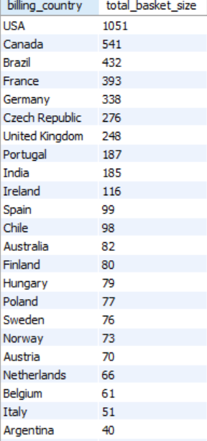
Visualisation:
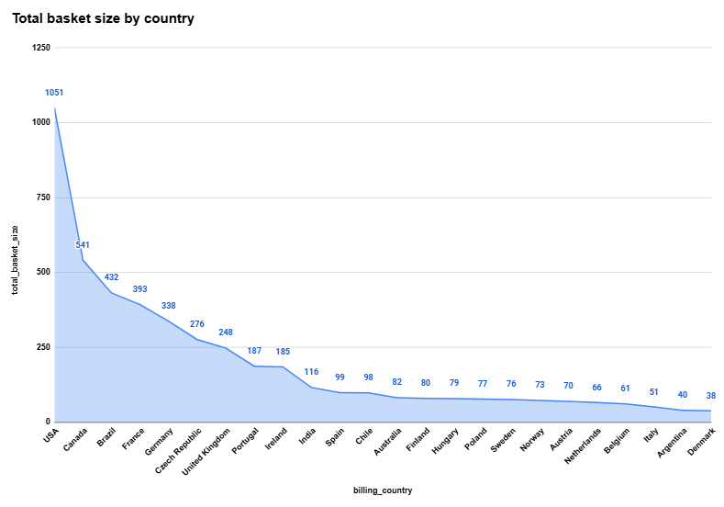
Approach :
- Objective: Calculate the total basket size (sum of quantities) for each billing country.
- Steps:
  - Join Tables: Combine invoice, invoice_line, and customer using their common keys (invoice_id and customer_id).
  - Group Data: Group by billing_country to calculate totals per country.
  - Aggregate: Use SUM(il.quantity) to get the total basket size for each country.
  - Sort: Order results by total_basket_size in descending order.
Insights :
- With a value of 1051, the USA significantly outperforms other countries in terms of total basket size.
- At 38, Denmark has the smallest total basket size among the listed countries.
- The data shows considerable variation in total basket size, suggesting differences in customer spending behavior, market size, or other factors across different regions.

Recommendations:
- Prioritize marketing and sales efforts in the top-performing countries (USA, Canada, Brazil). These countries contribute significantly to overall sales and represent opportunities for further growth.
- Investigate the reasons for lower basket sizes in countries like Argentina and Italy. This could involve analyzing factors such as product availability, pricing, and customer preferences in those markets.
- Consider localized strategies to improve basket size in underperforming countries. This might include offering targeted promotions, adjusting product assortments, or improving the customer experience in those specific regions.

4. Product Affinity Analysis: Which music genres, artists, or albums are frequently purchased together by customers? How can this information guide product recommendations and cross-selling initiatives?

Genres purchased together :
WITH GenrePurchases AS (
SELECT i.invoice_id, g.name AS genre
FROM invoice_line il
JOIN track t ON il.track_id = t.track_id
JOIN genre g ON t.genre_id = g.genre_id
JOIN invoice i ON il.invoice_id = i.invoice_id
)
SELECT
gp1.genre AS genre1,
gp2.genre AS genre2,
CONCAT(gp1.genre, " & ", gp2.genre) AS genre_combo,
COUNT(*) AS co_purchases
FROM GenrePurchases gp1
JOIN GenrePurchases gp2 ON gp1.invoice_id = gp2.invoice_id AND gp1.genre < gp2.genre
GROUP BY gp1.genre, gp2.genre
ORDER BY co_purchases DESC
LIMIT 10;
Output :
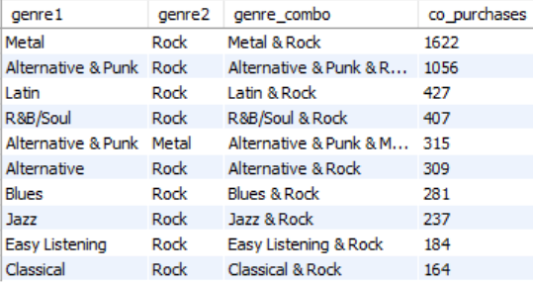

Insights :
- Rock appears in almost every combination, suggesting it is a popular choice alongside various other music styles.
- Metal and Alternative & Punk are often purchased together with Rock and even with each other, indicating potential overlap in their fan bases.
- The chart reveals distinct genre clusters forming the core of many combinations, while Metal and Alternative & Punk seem to be closely linked.
Recommendations :
- Prioritize marketing and promotional efforts for the most popular genre combinations. Focus on bundling or cross-promoting "Metal & Rock" and "Alternative & Punk & Rock" as they have the highest co-purchases.
- Explore opportunities to expand the reach of genres with lower co-purchases. Consider targeted campaigns or recommendations to introduce users to combinations like "Classical & Rock" and "Easy Listening & Rock."
- Analyze trends and preferences over time. Monitor co-purchase patterns to identify emerging trends and adjust marketing strategies accordingly.

Insights :
- Green Day is a central figure appearing in five of the top ten combinations, indicating a broad appeal across different rock subgenres.
- Combinations like Nirvana & The Rolling Stones, Eric Clapton & Nirvana, and Queen & U2 suggest that fans often purchase music from artists of a similar era or style.
- Green Day & Led Zeppelin have the highest co-purchase count (24), suggesting a particularly strong overlap in their fan bases.

Albums purchased together :
WITH AlbumPurchases AS (
SELECT i.invoice_id, al.title AS album
FROM invoice_line il
JOIN track t ON il.track_id = t.track_id
JOIN album al ON t.album_id = al.album_id
JOIN invoice i ON il.invoice_id = i.invoice_id
)
SELECT ap1.album AS album1, ap2.album AS album2,
CONCAT(ap1.album, " & ", ap2.album) as album_combo,
COUNT(*) AS co_purchases
FROM AlbumPurchases ap1
JOIN AlbumPurchases ap2 ON ap1.invoice_id = ap2.invoice_id AND ap1.album < ap2.album
GROUP BY ap1.album, ap2.album
ORDER BY co_purchases DESC
LIMIT 10;
Output :
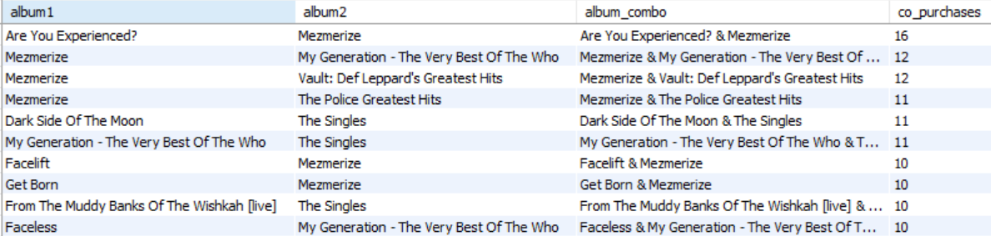
Insights :
- "Mezmerize" album appears in several of the top co-purchase combinations, suggesting it is often bought alongside other albums.
- "My Generation - The Very Best Of The Who" is also a popular album that appears twice in the top 10, indicating it is frequently purchased with other albums.
- Analyzing these co-purchase patterns can help recommend albums to customers based on their previous purchases. For example, if a customer buys "Mezmerize," the system could suggest "My Generation - The Very Best Of The Who".
Recommendations :
- Focus on bundling or cross-promoting albums like "Mezmerize" and "My Generation - The Very Best Of The Who" as they frequently appear together in purchases.
- Consider targeted campaigns or recommendations to introduce users to combinations like "Dark Side Of The Moon" and "The Singles."
- Monitor co-purchase patterns to identify emerging trends and adjust marketing strategies accordingly.

5. Regional Market Analysis: Do customer purchasing behaviors and churn rates vary across different geographic regions or store locations? How might these correlate with local demographic or economic factors?
Query :
SELECT
c.country,
c.state,
SUM(i.total) AS total_revenue,
ROUND(SUM(i.total) / COUNT(DISTINCT i.invoice_id), 2) AS avg_order_value,
ROUND(SUM(i.total) / COUNT(DISTINCT c.customer_id), 2) AS avg_revenue_per_customer
FROM customer c
JOIN invoice i ON c.customer_id = i.customer_id
GROUP BY c.country, c.state
ORDER BY avg_order_value DESC;
Output :
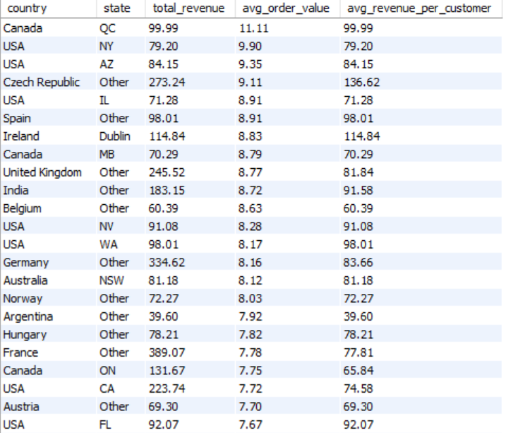
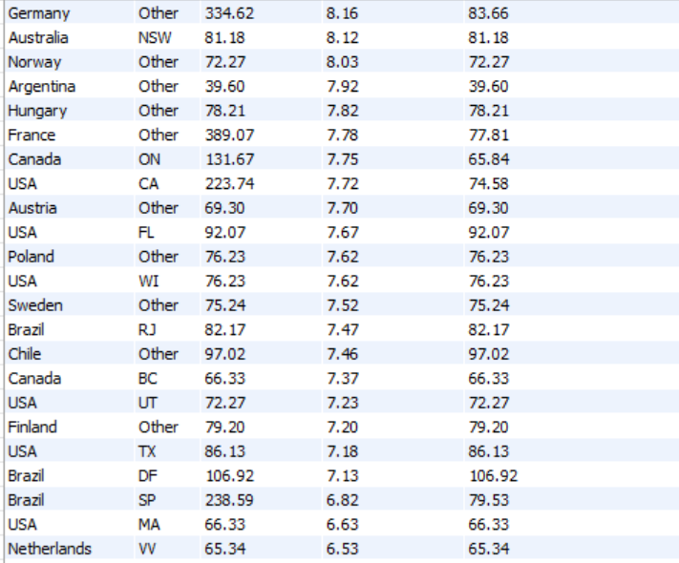
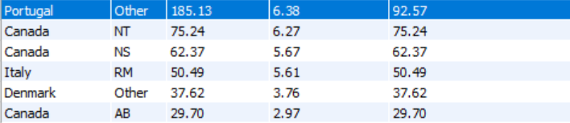

Visualizaion :
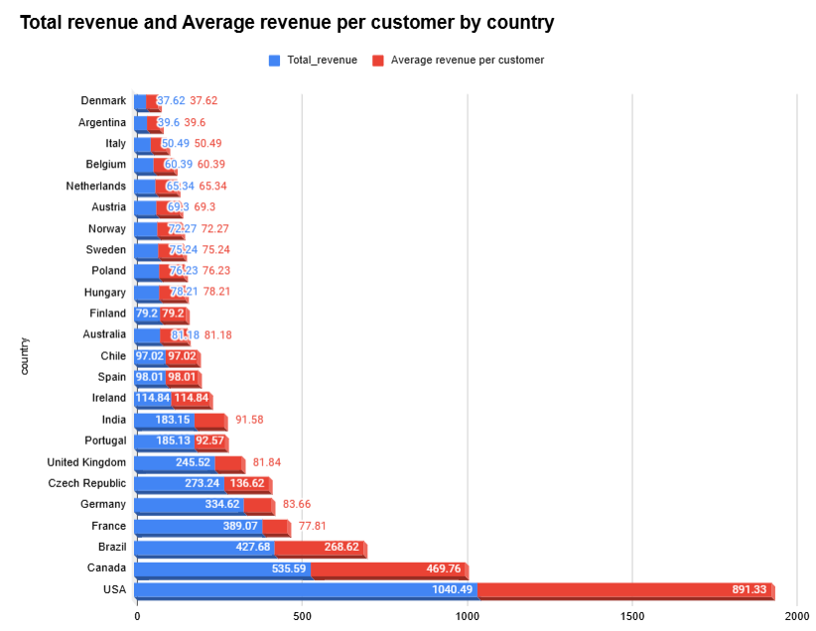
Insights :
- Developed countries like the USA, Canada, and Germany show higher total revenue and average spending per customer due to economic development and stronger economies.
- Larger populations contribute to larger market sizes and higher total revenue.
- Cultural factors and consumer behavior can influence average spending, and countries with higher average spending may have higher income inequality.
- This suggests a correlation between economic development and consumer spending power.
Recommendations :
- Prioritize marketing and sales efforts in countries with high total revenue and average revenue per customer, such as the USA, Canada, and the United Kingdom. These markets demonstrate strong customer spending and potential for continued growth.
- Investigate the reasons for lower revenue and average revenue per customer in countries like Denmark and Argentina. This could involve analyzing factors such as pricing, product offerings, and customer preferences in those markets.
- Consider localized strategies to improve revenue and customer engagement in underperforming countries. This might include offering targeted promotions, adjusting product assortments, or improving the customer experience in those specific regions.

6.Customer Risk Profiling: Based on customer profiles (age, gender, location, purchase history), which customer segments are more likely to churn or pose a higher risk of reduced spending? What factors contribute to this risk?
Query :
WITH frequency_factors as (
SELECT
C.customer_id, c.city,c.country,COUNT(i.invoice_id) AS purchase_frequency,MAX(i.invoice_date) AS last_purchase_date,
DATEDIFF ('2020-12-31 00:00:00', MAX(i.invoice_date)) AS days_since_last_purchase
FROM customer c LEFT JOIN invoice i ON c.customer_id = i.customer_id
GROUP BY c.country, c.city, c.customer_id
)
Select customer_id, country,purchase_frequency, days_since_last_purchase from frequency_factors
order by Days_since_last_purchase, purchase_frequency asc
Output :
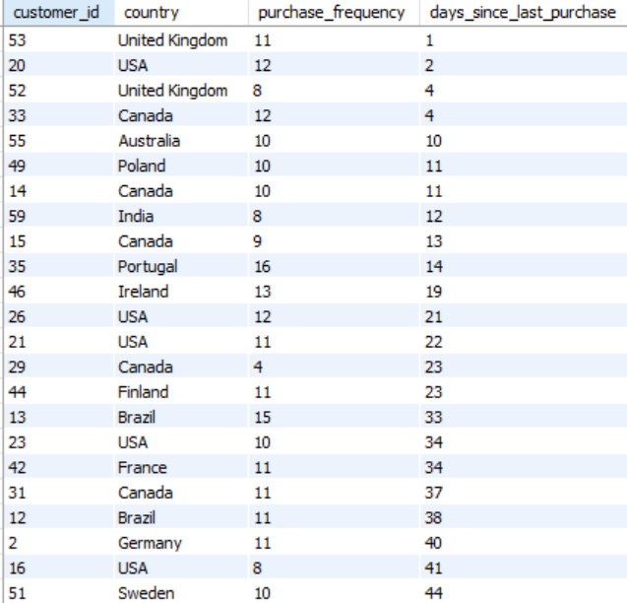
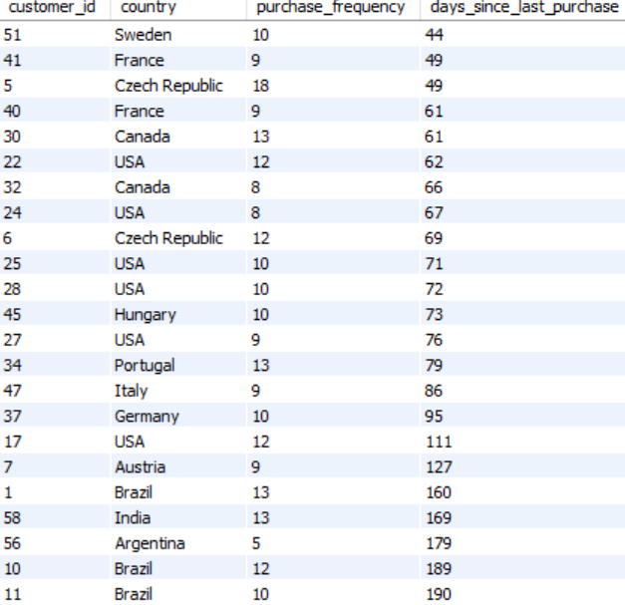
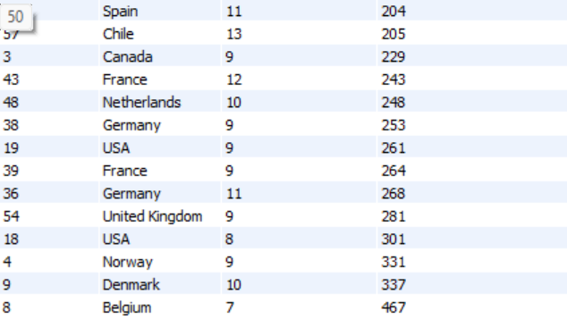
Visualisation :
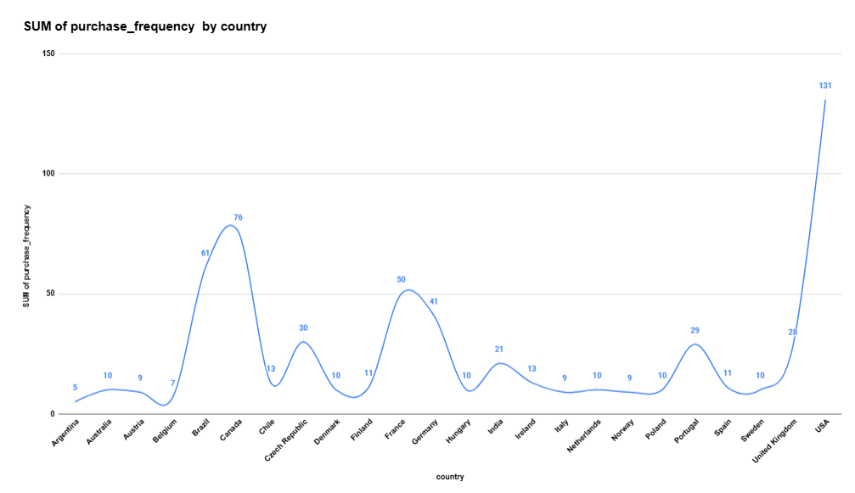
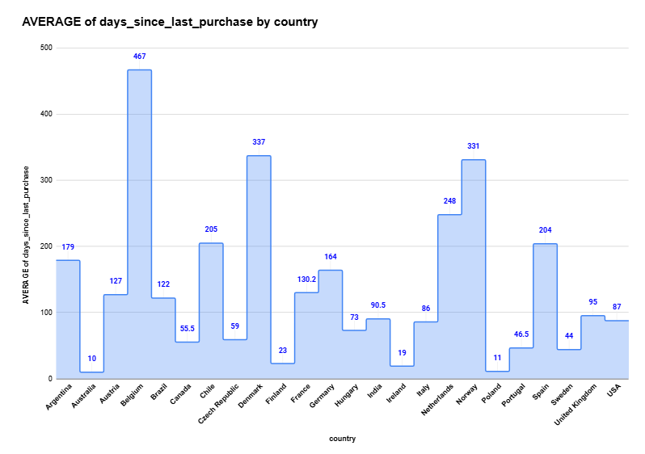
Approach :
- Common Table Expression (CTE):
  - The query starts by creating a CTE (frequency_factors) to calculate purchase-related metrics for customers grouped by country, city, and customer_id. Metrics include:
    - purchase_frequency: Total number of invoices for each customer.
    - last_purchase_date: Most recent purchase date for each customer.
    - days_since_last_purchase: Time elapsed (in days) since the customer's last purchase, relative to 2020-12-31.
- Main Query:
  - The final query retrieves the customer_id, country, purchase_frequency, and days_since_last_purchase from the CTE.
  - Results are ordered:
    - Primarily by days_since_last_purchase (ascending) to identify customers based on their recency.
    - Secondarily by purchase_frequency (ascending) to highlight less frequent purchasers.

Insights :
- The United States has the highest purchase frequency. This suggests strong customer engagement and a large market potential in the US.
- There is significant variation in purchase frequency across countries. Some countries like the USA and Germany show high activity, while others like Argentina and Austria have relatively low purchase frequencies.
- Understanding the reasons for these variations could inform targeted marketing strategies and improve customer engagement in countries with lower purchase frequencies.

- Some countries like Argentina and Austria have much longer average days since the last purchase, indicating lower customer activity compared to countries like the USA and the Netherlands.

- Countries like the USA and the Netherlands demonstrate higher customer engagement and repeat purchase behavior. This suggests a strong customer base and potential for further growth in these markets.

Recommendations to reduce churn risk:
- Targeted campaigns: Implement targeted campaigns to re-engage customers in countries with high churn risk.
- Personalized offers: Offer personalized incentives and rewards to encourage repeat purchases.
- Improve customer experience: Enhance customer service and provide a seamless shopping experience to build stronger customer relationships.

7. Customer Lifetime Value Modeling: How can you leverage customer data (tenure, purchase history, engagement) to predict the lifetime value of different customer segments? This could inform targeted marketing and loyalty program strategies. Can you observe any common characteristics or purchase patterns among customers who have stopped purchasing?
Purchase History Analysis query:
SELECT i.customer_id,COUNT(i.invoice_id) AS total_orders,
SUM(i.total) AS total_spent,ROUND(AVG(i.total), 2) AS avg_order_value
FROM invoice i JOIN customer c ON i.customer_id = c.customer_id
GROUP BY i.customer_id, c.first_name, c.last_name
ORDER BY total_spent DESC;
Output :
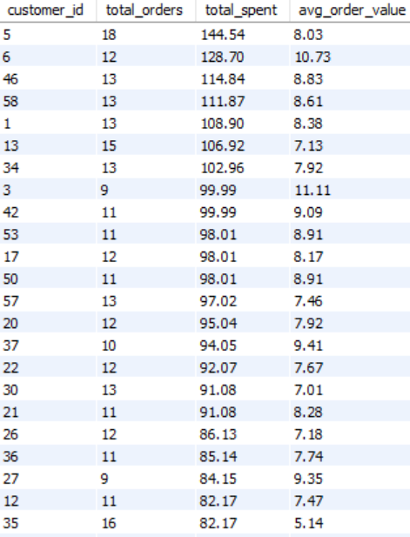
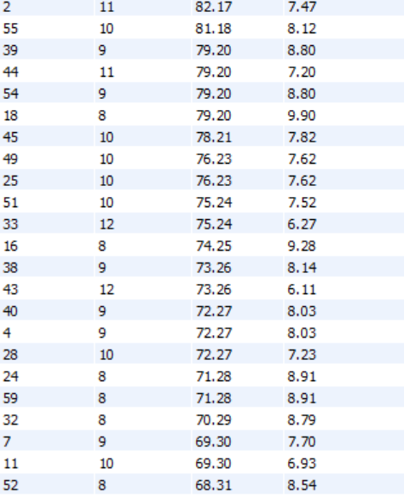
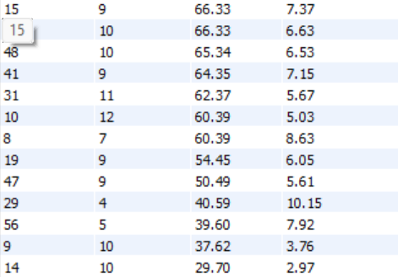
Visualisation :
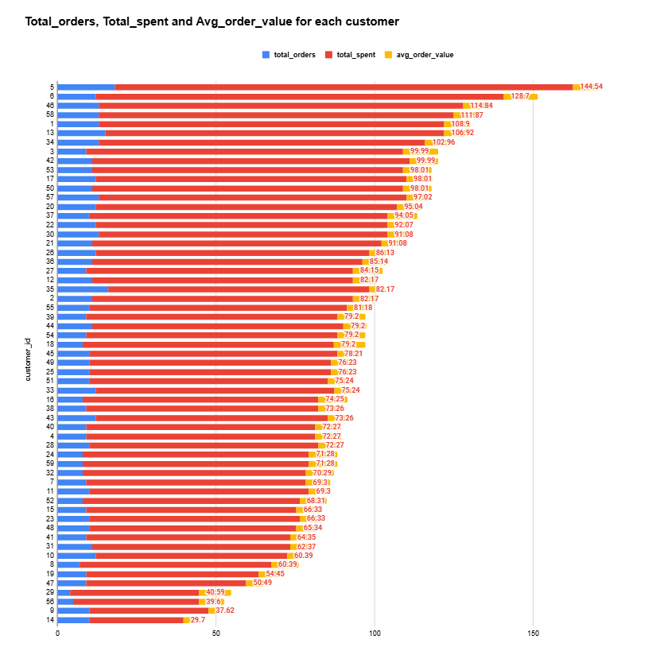
Approach :
- The total number of orders (total_orders) placed by each customer.
- The total amount spent (total_spent) by each customer.
- The average order value (avg_order_value) for each customer. It joins the invoice table with the customer table, groups the results by customer, and sorts the customers by their total spending in descending order.

Insights:
- High Spending but Low Frequency: Customer 29 has spent a total of $40.59 with an impressive average order value of $10.15, but they have only made 4 purchases, indicating a high-value customer with low order frequency. This could be a potential area to encourage more frequent purchases through targeted offers.
- Consistent Customers: Customers like 5, 6, and 46 have made multiple orders (18, 12, and 13 respectively) with moderate average order values (around $8.00 - $10.00). These customers show a consistent purchasing behavior, making them prime candidates for loyalty programs.
- Low-Value but Frequent Orders: Customer 9 has made 10 orders, but their total spending is relatively low at $37.62, with a very low average order value of $3.76. This might indicate the customer is buying lower-cost items or smaller quantities, suggesting a strategy to increase average spend per order.

Recommendations :
- Target High-Spending Customers: Based on the output, focus marketing efforts on customers who have the highest total spending. Tailor loyalty programs or exclusive offers for these customers to encourage repeat business.
- Customer Segmentation: Analyze the average order value to identify customers who place frequent but smaller orders versus those with fewer but larger purchases. This can help in crafting personalized offers or product bundles.
- Promotions Based on Frequency: For customers with many orders but lower total spending, consider offering targeted discounts or promotions to increase their average order value.
8. If data on promotional campaigns (discounts, events, email marketing) is available, how could you measure their impact on customer acquisition, retention, and overall sales?
Customer acquisition query :
-- Assuming Campaign Period between Jan 1st 2020 - Mar 31st 2020
SELECT
COUNT(DISTINCT c.customer_id) AS new_customers,
(COUNT(DISTINCT c.customer_id) * 100.0) /
(SELECT COUNT(DISTINCT customer_id) FROM customer) AS new_customer_percentage
FROM customer c
JOIN invoice i ON c.customer_id = i.customer_id
WHERE i.invoice_date BETWEEN '2020-01-01' AND '2020-03-31';

Customer acquisition output :
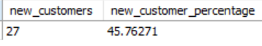
Approach:
Calculated the number and percentage of new customers who made a purchase between January 1, 2020, and March 31, 2020. ( Assuming Campaign Period between Jan 1st 2020 - Mar 31st 2020 )
Insights :
- The percentage of new customers during the campaign period (January 1, 2020, to March 31, 2020) is 45.76%, which indicates a significant portion of customers acquired during this time were new to the business.
- It suggests that the marketing or promotional efforts during this campaign were effective in attracting new customers.

Recommendations :
- Analyze how effectively the campaign retained the acquired customers beyond the initial purchase.
- Targeted emails, loyalty programs, and exclusive offers to encourage repeat purchases.
- Providing excellent customer service, addressing customer concerns promptly, and ensuring a seamless purchase journey.

Promotion period orders query :
SELECT CASE
WHEN invoice_date < '2018-01-01 00:00:00' THEN 'Before Promotion'
WHEN invoice_date BETWEEN '2018-01-01 00:00:00' AND '2018-03-31 00:00:00' THEN 'During Promotion'
ELSE 'After Promotion'
END AS promotion_period,SUM(total) AS total_revenue,COUNT(invoice_id) AS total_orders
FROM invoice WHERE invoice_date BETWEEN '2017-10-01 00:00:00' AND '2018-06-30 00:00:00' -- Analyzing a wider range
GROUP BY promotion_period

Output :
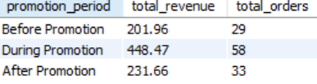

Visualisation :
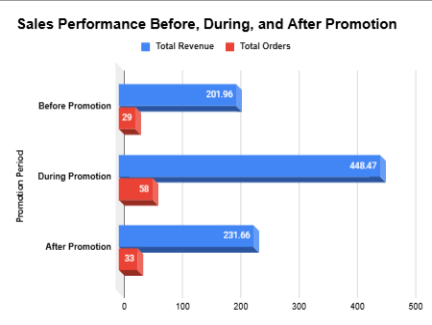
Approach :
- Objective: Analyze revenue and order volume across three periods: before, during, and after a promotion.
- Logic:
  - A CASE statement categorizes the invoice_date into three periods: Before Promotion, During Promotion, and After Promotion.
  - Aggregates are calculated for each period:
    - SUM(total) for total revenue.
    - COUNT(invoice_id) for total orders.
- Filters: The query narrows down the analysis to invoices between 2017-10-01 and 2018-06-30.
- Grouping: Groups results by the promotion period

Insights :
- The total revenue more than doubled during the promotion period compared to both before and after.
- The number of orders also increased substantially during the promotion, indicating that customers were more likely to make purchases when the promotion was active.
- The AOV increased slightly during the promotion, suggesting that customers were likely to spend more per order during the promotion.
Recommendations:
- Identify the key elements of the promotion that resonated with customers and consider replicating them in future campaigns.
- Analyze customer behavior, competitor activity, and market trends to understand the factors contributing to the drop-off and develop strategies to maintain the increased sales level.
- This could involve targeted campaigns, loyalty programs, or exclusive offers to retain customers and encourage repeat purchases.

9. How would you approach this problem, if the objective and subjective questions weren't given?
Step 1: Understand Business Goals
Is the focus on acquisition, retention, or revenue growth?
Are promotions intended for new or existing customers?
Step 2: Data Exploration
Check historical sales trends before promotions.
Identify customer behavior patterns using cohort analysis.
Step 3: Generate Hypotheses
Example: "Did discounts increase customer retention?"
Example: "Do customers who receive promotional emails spend more?"
Step 4: Run Queries and Analyze Data
Time-series analysis of sales trends.
Segmentation of customers based on buying behavior.
Comparative analysis using A/B testing or control groups.
Step 5: Interpret Insights and Optimize Campaigns
If retention is low, improve personalized offers.
If discounts increase sales but reduce profits, adjust pricing strategy.
If email open rates are low, improve email marketing content.
10. How can you alter the "Albums" table to add a new column named "ReleaseYear" of type INTEGER to store the release year of each album?
Query :
ALTER TABLE Albums
ADD COLUMN ReleaseYear INTEGER;

11.Chinook is interested in understanding the purchasing behavior of customers based on their geographical location. They want to know the average total amount spent by customers from each country, along with the number of customers and the average number of tracks purchased per customer. Write an SQL query to provide this information.
Query :
SELECT
c.Country,
COUNT(DISTINCT c.Customer_Id) AS NumberOfCustomers,
ROUND(AVG(t.TotalSpent),2) AS AverageTotalSpent,
ROUND(AVG(t.TrackCount),2) AS AverageTracksPurchasedPerCustomer
FROM Customer c
JOIN (
SELECT i.Customer_Id,
SUM(i.Total) AS TotalSpent,COUNT(il.Track_Id) AS TrackCount
FROM Invoice i
JOIN Invoice_line il ON i.Invoice_Id = il.Invoice_Id
GROUP BY i.Customer_Id )
t ON c.Customer_Id = t.Customer_Id
GROUP BY c.Country
ORDER BY AverageTotalSpent DESC;
Output :
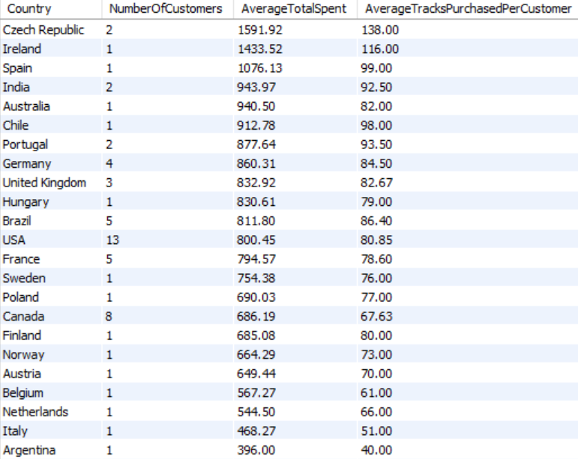

Approach:
- Join Tables: The Customer table is joined with a subquery that calculates the total spending (TotalSpent) and the number of tracks purchased (TrackCount) for each customer.
- Subquery Calculation: The subquery aggregates data by Customer_Id to sum up the total spent and count the tracks purchased.
- Group and Aggregate: The final query groups the data by Country, counts the distinct number of customers, and calculates the average spending and average tracks purchased per customer for each country.
- Order Results: The results are ordered by AverageTotalSpent in descending order to highlight the countries with the highest average spending.

Insights :
- The USA has the largest customer base: With 13 customers, the USA has the highest number of customers compared to other countries.
- Canada and France have the next largest customer bases: Following the USA, Canada and France have the next highest number of customers, with 8 and 5 customers respectively.
- A significant number of countries have only 1 or 2 customers, indicating a limited market presence in those regions.

Recommendations:
- Target High-Spending Countries: Focus marketing campaigns on countries with the highest average spending and track purchases to further enhance customer retention.
- Encourage Track Purchases: For countries with lower average track purchases, consider offering personalized promotions or discounts to increase the number of tracks purchased per customer.
- Customer Engagement: Analyze the engagement in high-spending countries to create loyalty programs that reward repeat customers.

